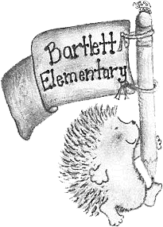
BARTLETT PTA
Bartlett Elementary School
689 Mast Road
Manchester, NH 03102
www.bartlettpta.org
@NHBartlettPTA
Please support the Bartlett PTA today by joining our PTA membership! The cost is only $10 per school year which goes toward programs for the students, teachers, and school. The PTA also offers additional educational events and entertainment like family movie nights, holiday events, father/daughter dance, mother/son dance, story nights, special visits, and more!
Your membership alone will give us a BIGGER voice in our school and community. Your membership dues of $10 comes with no obligation, but we are always looking for more volunteers. Whether you have 30 minutes or a few hours a month—volunteering with the PTA doesn’t have to take a lot of time. Maybe it’s dropping off a box of cookies or decorations for an upcoming event, helping hand out carnations, or maybe it’s an hour helping with popcorn on Fridays (it’s a Bartlett tradition!). Anyone can help and we are always in need of volunteers.
Budget, programs, school events, and volunteer opportunities are discussed at a monthly meeting (attendance is not mandatory, but we provide free childcare, coffee, snacks, and a door prize!) We would love for you to join us at our next meeting and see all the awesome things Bartlett PTA has to offer!
ANNUAL PTA MEMBERSHIP FORM 2022–2023
Please return this form to Bartlett with your $10 per person annual membership dues.
Please make checks payable to Bartlett PTA. Thanks for joining!
Name: ______________________________________________________________________
Address: ____________________________________________________________________
Telephone: ___________________________________________________________________
Email: _______________________________________________________________________
Child’s Name: ________________________________________________________________
2nd Child’s Name:______________________________________________________________
Child’s Grade and Teacher: ______________________________________________________
2nd Child’s Grade and Teacher:____________________________________________________
Amount enclosed: _____________
Method of payment: Check #:_______ Cash:________

