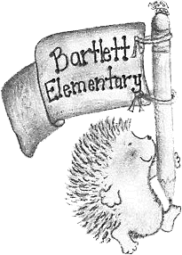
BARTLETT PTA
Bartlett Elementary School
689 Mast Road
Manchester, NH 03102
www.bartlettpta.org
@NHBartlettPTA

Dear Bartlett Families,

The Bartlett PTA would like to welcome all the new and returning families to the Bartlett community! We are very excited for an exciting and successful 2022–2023 school year!

The PTA is an organization that partners with parents, teachers, staff, and our community to bring fun and educational programs, events, services, and opportunities to our children to enrich their academic experience. Bartlett is a community, based on vibrant parent involvement. Your contribution, whether it is your time, knowledge, or resources, make a difference! We invite you to become an involved member of the Bartlett community by joining the Bartlett PTA.

The Bartlett PTA provides funding for field trips, birthday books, classroom library support, school library funding, creating the Bartlett Directory, organizing book fairs, father/daughter and mother/son events, ice cream socials, pizza parties, assemblies, field day, and so much more! These events enhance our children’s educational experience and help to make our school a fun and supportive community. These activities and events require volunteers to help make them successful.

We want you to become part of the PTA to help plan these amazing activities! Membership is $10 annually per member and meets once a month in the evening at the school with free childcare provided! (Note that meetings may also be conducted via Zoom.) The annual membership fee helps to support the many activities the PTA coordinates. Even if you are not able to donate your time to the PTA, think about becoming a member to help support the cost of events.

If this sounds like something you’d like to be part of, please fill out the attached membership form and return it to the office. We ask that you put the form and payment in an envelope labeled Bartlett PTA so the office will make sure it gets to us.

To stay informed and connected to all Bartlett PTA news and events, please visit our website at www.bartlettpta.org and follow us on Facebook at Bartlett PTA (@NHBartlettPTA).

We look forward to another amazing school year and hope to get many more of you involved with the PTA! If you have any questions or would like to share some of your thoughts and suggestions, please feel free to contact any Bartlett PTA Board Member.

Sincerely,

2022–2023 Bartlett PTA Board Members

